Affectation or Theatrical Diction

🎭 What is Affectation or Theatrical Diction
# Source: AI Source: Provided by: [Data Path: Persons Table -> ID Column: 1, Name_En Column: Motasem Essam] -> From: [Chatgpt (GPT-4-turbo)] on [7/30/2025]
Affectation or Theatrical Diction refers to exaggerated, artificial, or overly dramatic speech patterns used to impress, perform, or convey heightened emotion. It may sound unnatural or pretentious and is often associated with stage performance, public speaking, or stylized characters in literature or film.

✅ Key Features:
# Source: AI Source: Provided by: [Data Path: Persons Table -> ID Column: 1, Name_En Column: Motasem Essam] -> From: [Chatgpt (GPT-4-turbo)] on [7/30/2025]
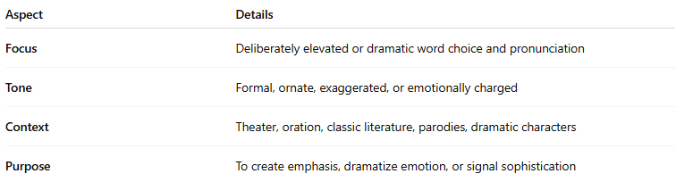
Aspect | Details
Focus | Deliberately elevated or dramatic word choice and pronunciation
Tone | Formal, ornate, exaggerated, or emotionally charged
Context | Theater, oration, classic literature, parodies, dramatic characters
Purpose | To create emphasis, dramatize emotion, or signal sophistication

🎙️ Examples of Theatrical/Affected Diction:
# Source: AI Source: Provided by: [Data Path: Persons Table -> ID Column: 1, Name_En Column: Motasem Essam] -> From: [Chatgpt (GPT-4-turbo)] on [7/30/2025]
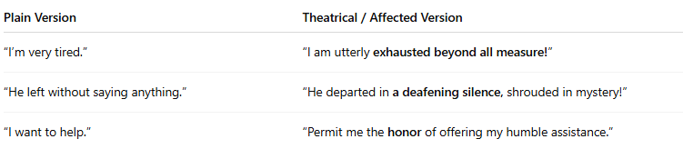
Plain Version | Theatrical / Affected Version
“I’m very tired.” | “I am utterly exhausted beyond all measure!”
“He left without saying anything.” | “He departed in a deafening silence, shrouded in mystery!”
“I want to help.” | “Permit me the honor of offering my humble assistance.”

🧠 Common Traits:
# Source: AI Source: Provided by: [Data Path: Persons Table -> ID Column: 1, Name_En Column: Motasem Essam] -> From: [Chatgpt (GPT-4-turbo)] on [7/30/2025]
- Use of archaic or elaborate words (“thou,” “behold,” “alas”)
- Over-articulation or excessive enunciation
- Poetic structure in casual speech
- Mimics classical or literary tones (e.g., Shakespearean English)
- Often found in dramatic monologues, stage acting, or mock-serious speech

🆚 Theatrical vs Neutral Diction:
# Source: AI Source: Provided by: [Data Path: Persons Table -> ID Column: 1, Name_En Column: Motasem Essam] -> From: [Chatgpt (GPT-4-turbo)] on [7/30/2025]
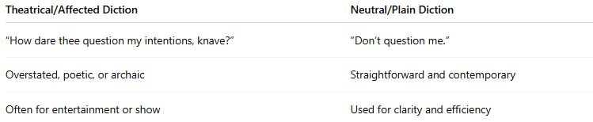
Theatrical/Affected Diction | Neutral/Plain Diction
“How dare thee question my intentions, knave?” | “Don’t question me.”
Overstated, poetic, or archaic | Straightforward and contemporary
Often for entertainment or show | Used for clarity and efficiency

🧭 Seen In:
# Source: AI Source: Provided by: [Data Path: Persons Table -> ID Column: 1, Name_En Column: Motasem Essam] -> From: [Chatgpt (GPT-4-turbo)] on [7/30/2025]
- Drama and theater
- Satire or parody
- Classical literature
- Speech competitions
- Rhetorical or ceremonial speech

⚠️ Note:
# Source: AI Source: Provided by: [Data Path: Persons Table -> ID Column: 1, Name_En Column: Motasem Essam] -> From: [Chatgpt (GPT-4-turbo)] on [7/30/2025]
While it adds drama and flair, affectation can come off as unnatural or pretentious if misused in everyday conversation. However, when intentionally stylized, it can enhance tone, humor, or gravitas.

